2024
ANNUAL REPORT

GREEN COUNTY LAND AND WATER CONSERVATION
1627 4th Avenue West
Monroe, Wisconsin 53566
(608) 325-4195

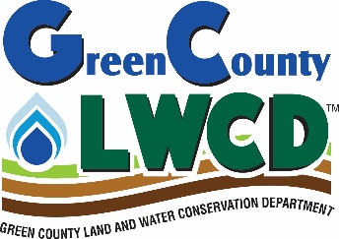
THE LAND AND WATER CONSERVATION DEPARTMENT has three full time staff members: Todd Jenson, Tonya Gratz, and Tess Wallner (who left in September and was replaced by Mason Jarosinski), plus a summer intern, Jenna Allison.

Our mission: Help others to keep the soil on the fields, and the nutrients out of the streams and groundwater.
Our methods: Education, technical assistance, and administering government programs that wisely encourage conservation.

The county staff in conjunction with the Natural Resources Conservation Service (NRCS) federal staff of Jason Thomas, Emily Colson (who left in October), Chelsea Starr, Kristin Day, Justin Edgel, and Becky Hardyman are located within the same office space. Each agency has some programs they strictly handle; however, most of the programs are shared between each to some degree.

THE LAND AND WATER CONSERVATION COMMITTEE is the policy making body of the Green County Board of Supervisors responsible for oversight of the Land and Water Conservation Department. The Committee consists of Kristi Leonard, Nick Hartwig, Peg Sheaffer, Paul Roemer, Erica Roth, Sam Wilke, and citizen member, Dudley Timm.

PROGRAM NARRATIVES

Land and Water Resource Management
Green County received money for the installation of conservation practices through this program. $87,705 was received in bonding revenue for structural practices. The majority of the practices installed were well abandonment, grassed waterways, stream crossings, streambank improvement, and manure storage. We utilized $19,444 from DATCP for the use of writing nutrient management plans on 486 acres.

Tree Planter, Sprayer Rental, and Tree Sales
The LWCD owns two tree planters that landowners may rent for a nominal fee. They both got work done on them. They were cleaned, repainted, and got new hydraulic hoses. One of them also got a new seat and new tires. The LWCD also owns a dozen tree spuds that are loaned out for the hand planting of trees and shrubs. A tank sprayer and a backpack sprayer are available for grass and weed control when establishing tree and wildlife plantings. We held our annual tree sale. Trees that were sold include: bur oak, red oak, swamp white oak, sugar maple, white pine, Norway spruce, apple, American plum, aspen, tamarack, arborvitae, serviceberry, and elderberry. Trees ranged from 1 – 4 feet in height. 7800 trees were sold plus root gel and fertilizer packs.

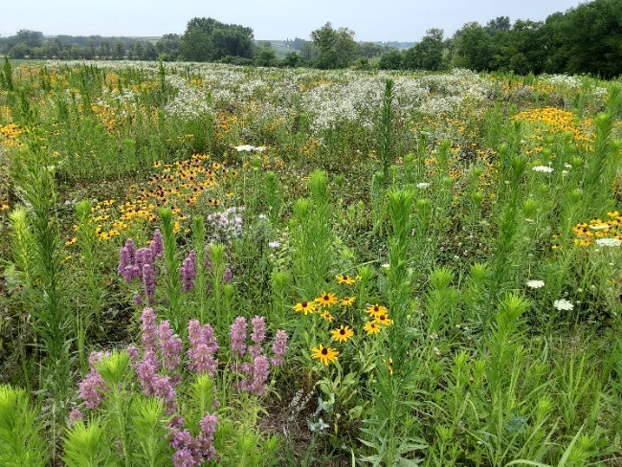
Conservation Reserve Enhancement Program and CRP This program has a $200 million budget of federal money and $40 million of state money. CREP is designed to improve water quality and wildlife habitat. Riparian buffers and filter strips are the two main practices installed. Targeted areas are cropland or pasture within 150 feet on either side of streams. For every $1 of state money, the federal government pays out $5. In 2024, 4 landowners enrolled in the program with 36 acres. Department staff stake out the buffers and filter strips, GPS them, if necessary, write the fifteen year or perpetual contract with the landowner, and do status reviews on the fields after the practice is implemented. Staff wrote 32 CRP contracts and did field verifications on 82 contracts for current cover. The department also has a contribution agreement with NRCS for work done on CRP and CREP contracts. This contract lasts for three years and pays up to $50,000 for the life of the contract.

Trout Stream Success
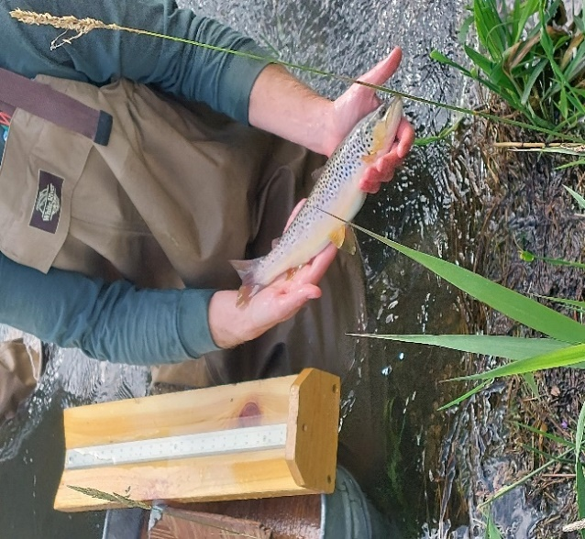
Our office has been working with landowners doing quite a bit of streambank restoration on Bushnell Creek. Below Cty. J is not considered trout water. The DNR had not shocked the stream since 2012. They also have not been stocking it with trout. Todd had been fishing some recently completed restoration work and was catching a lot of fish. He requested the DNR to check out the stream again. In July, they shocked a small portion of the stream and got 64 trout ranging from 2 – 16 inches in length. There is natural reproduction going on! The DNR is going to reclassify the stream from no classification to a class 2 trout water.

Invasive Species Control
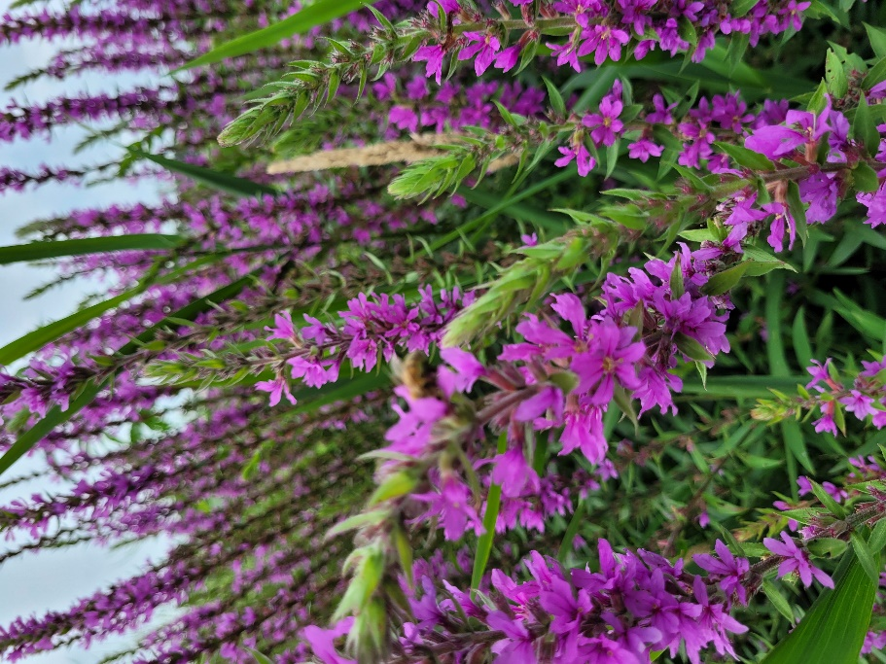
We had been working with the Upper Sugar River Watershed Association to have phragmites eradicated. We have eradicated twelve patches in the last few years. This year no work was done; however, we found two more patches of phragmites throughout the county. We currently have eight known patches of it. We will be in contact with them again to get those spots under control. The area on Cty. S, just north of Juda, has had the purple loosestrife that we thought we had under control, reemerge. There will be a focused effort to reduce and to eradicate it. We also need to work with USRWA on controlling Japanese knotweed.

Farmland Preservation/Working Lands Initiative
This program is administered by Green County for DATCP. Landowners collect income tax credits for agreeing not to develop their land, to limit soil erosion, meet manure handling standards, and to develop a nutrient management plan. In 2024, there were 19 landowners in Green County that participated in the program. Approximately 3400 acres are enrolled. Two landowners have modified their contract to get a base tax credit of $5 per acre per year.
The Working Lands Initiative replaced the Farmland Preservation Program on July 1, 2009. Landowners who have an existing contract would continue to get tax credits until the contract’s expiration date. If new landowners wish to participate in this program, they will need to be in an Ag Enterprise Area or the township to be exclusive ag zoned. Also, our office hired Southwestern Wisconsin Regional Planning Commission to rewrite the county’s Farmland Preservation Plan, which was due to expire at the end of 2024.

Youth Poster Contest
We host an annual poster contest for youth to participate in, ages K – 12. 107 posters were submitted in four of the five age categories. The top poster in each category was sent to the Southern Area Association for judging in the area event. Two posters received third at the area contest. The theme was May the Forest be With You, Always.

Youth Conservation Days
Two youth conservation days were held at Honey Creek Park in Monroe. Approximately 202 fifth grade students took part in the events held in May and October. Participating schools were Monroe Northside, Abe Lincoln, Juda, Monroe Parkside, and Monticello. Students learned about soil, forestry, water invertebrates, fish management, prairies, watersheds, soil and water conservation, aquatic invasives, wildlife calls, groundwater, native American artifacts, homing pigeons, pollinators, recycling, and ways a farmer conserves soil.

Wildlife Damage Abatement

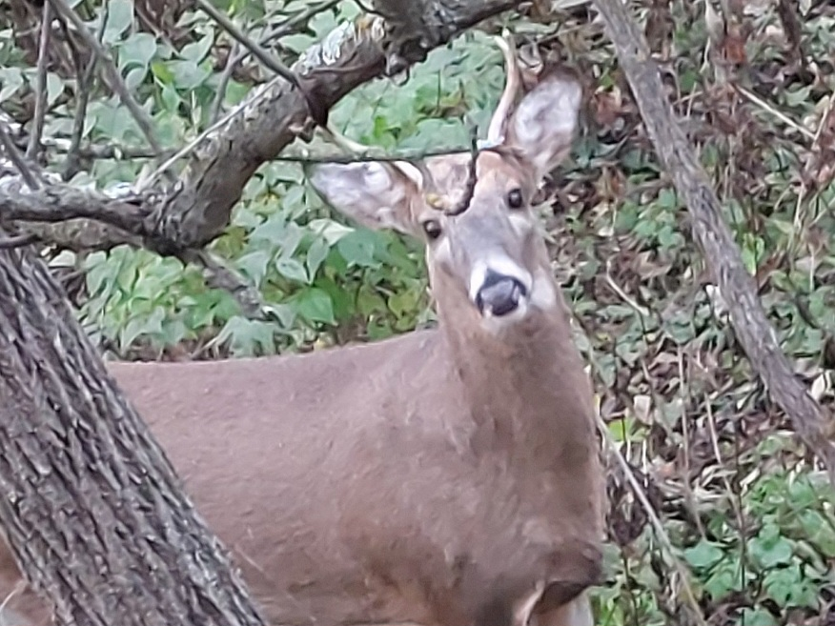
This program is funded by the DNR’s $12 bonus deer permit system, as well as, $2 from every hunting license sold, and is administered by USDA-WS (Wildlife Services). Landowners can file for crop damages from deer, turkey, geese, and bear. Fencing and/or pyrotechnics are available through this program to keep the identified species away from crops. If that does not work, hunting of the species may be recommended. Three landowners were issued a total of 25 tags for deer hunting based on excessive damage. 19 of the tags were filled. We had one landowner sign up again for electric bear fencing for his bee hives. No shooting permits were issued. We also had one person sign up for goose fencing. No shooting permits were issued.

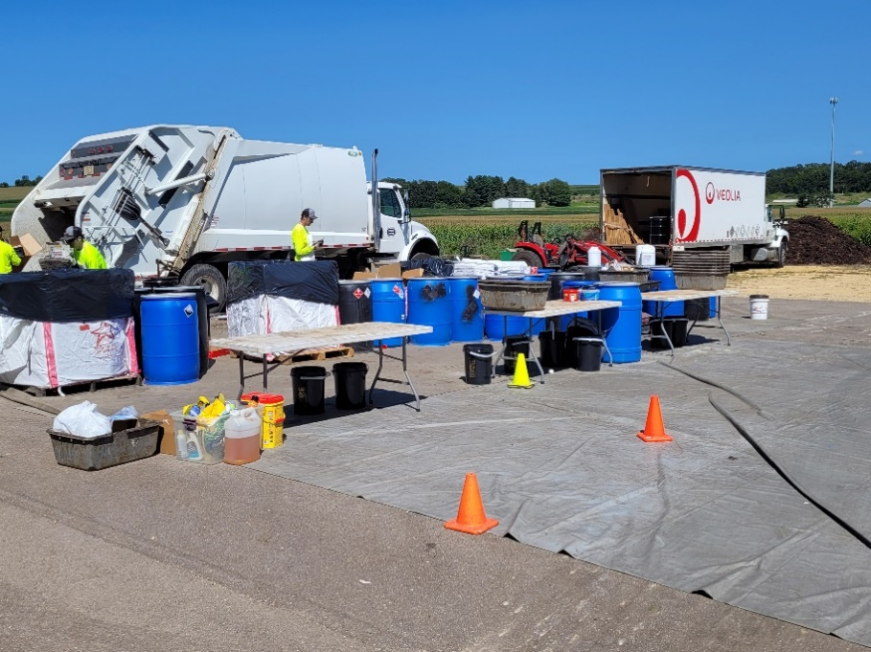
Clean Sweep In 2024 our department took over administering the Clean Sweep Program. The event was held at the Monticello Recycling Center in August. We had 163 participants that brought in 8281 pounds of household waste and 2579 pounds of agricultural waste. We also had a prescription drop-off at the event. The Green County Health Department, Sheriffs Department, and Monticello Public Works helped with the event.

Private Water Systems Ordinance
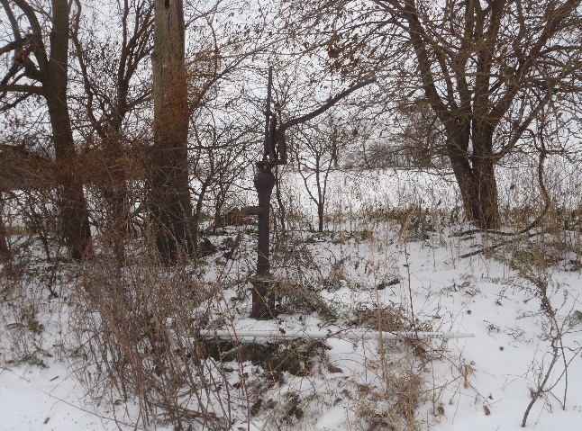
This ordinance requires the owner of a private water well that has not been used in three years to properly abandon it. 27 wells were properly abandoned in 2024. The Land and Water Conservation office has developed a tracking system and has records of 1410 wells that have been properly abandoned to date. Every fall, landowners who have old, unused wells that are discovered, are sent a letter offering cost-sharing to fill in the well. After three years and three letters, if the landowner has still not done anything to remedy the situation, the matter is then turned over to Corporation Counsel for legal action. We also have an ordinance to ensure the proper placement of new wells. Permits were issued for 83 new wells in 2024. These wells are located by GPS and inspected by staff.

Wisconsin Women in Conservation (WiWiC)
WiWiC is a state-wide collaborative effort led by the Michael Fields Agricultural Institute in partnership with Renewing the Countryside, Marbleseed, and Wisconsin Farmers Union. A three-year project is funded by the USDA-NRCS, brings together Wisconsin women landowners to connect and learn about conservation practices, resources, and funding opportunities. Tonya has walked farms with 30 women landowners to give them ideas of opportunities of how to improve their land and resources of how to get practices applied. After the walkover, she wrote a conservation plan for each landowner. She did seven plans in 2024. Our office is reimbursed $500 for each plan.

Drainage Board
The Land and Water Conservation Department has been working with the Green County Drainage Board. The Drainage Board oversees four districts within the county: District #1 (Juda Branch) developed in 1914, District #2 (Little Sugar River) developed in 1951, Broughton District (Norwegian Creek) developed in 1914, and the Decatur District (Sylvester Creek) developed in 1914. The purpose of creating these districts was to straighten the streams to improve drainage, improve agricultural cropland, and to disperse water as quickly as possible. Currently the Drainage Board is working to have each landowner clear and maintain trees that are on or in the streambank corridor. By rule, there is to be a 20-foot-wide grass buffer along the top of the streambank, with no trees growing. This is for access to the drainage district if work needs to be done. A minimal amount of work was done in the districts this year.

Land Judging Contest
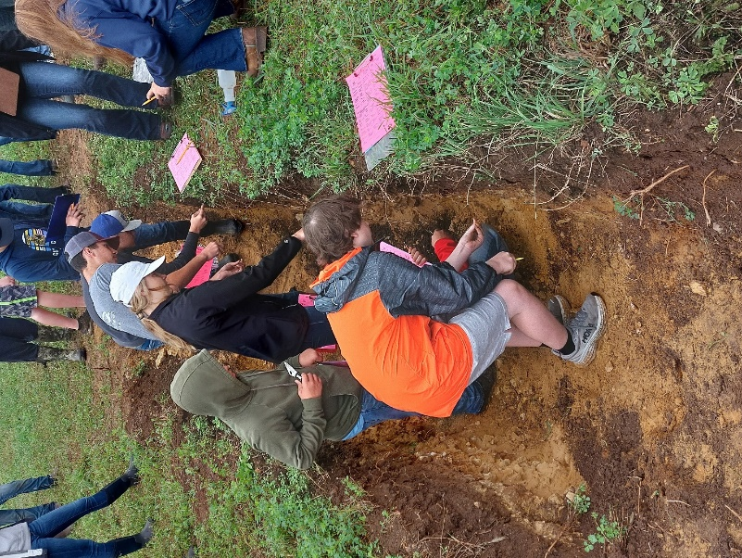
Green County hosted the annual contest at the Russell and Nicole Meinert and Brock Binder farm just southwest of Monroe. Participating schools were Argyle, Black Hawk, Cassville, Cuba City, Dodgeville, Fennimore, Juda, Lancaster, Milton, Monticello, Mt. Horeb, Pecatonica, Platteville, Potosi, Prairie du Chien, River Ridge, and Shullsburg. A total of 184 students participated in the contest from 17 schools. The students reviewed four soil pits and evaluated soil properties, estimated slope, ranked land classes, and recommended conservation practices in the contest. This contest is co-sponsored by Rufer and Son Excavating, who dig the soil pits for free. We also co-hosted the state contest with Blackhawk Technical College. This year’s event was held at the Roger and Cheri Johnson farm near Juda. Schools participating were from: Argyle, Bay Port, Beaver Dam, Black Hawk, Cassville, Cochrane-Fountain City, Cuba City, DeForest, Dodgeville, Elkhorn, Fennimore, Juda, Lake Mills, Lancaster, Milton, Monticello, Mt. Horeb, Hudson, Pecatonica, Platteville, Potosi, Prairie du Chien, Riverdale, River Ridge, Scales Mound, Seneca, Shullsburg, Spooner, Sun Prairie East, and, Sun Prairie West. A total of 203 students participated in this contest from 30 schools. The top five teams advance to the national contest in Oklahoma. In local teams, Monticello placed second, and Black Hawk was fourth.

Outstanding Employee Award
Tonya was selected as the Outstanding Soil Conservationist in Wisconsin for 2024. This award is presented annually by Wi Land and Water. She accepted the award at their annual statewide conference in Green Bay.
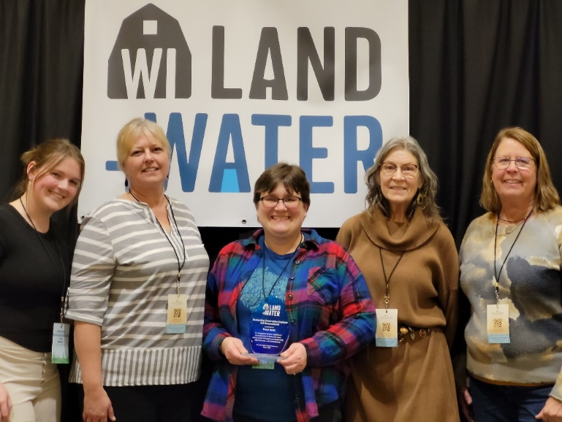

Farmers of the Sugar River

Pinnacle Dairy hosted a tour of their farm. 14 people attended despite the 0-degree temperature (-21 windchill). They toured the parlor, calf barn, separation buildings and digester (natural gas command center).
New Glarus’ Tofflers was the meeting and eating spot for the first Roundtable that 10 farmers shared successes, challenges and ideas.
The Albany Lions Club hosted and fed the 93 attendees of the Annual Meeting. There was a fascinating presentation from the DNR about mussels in the Sugar River, producer-led update and an overview of a soil phosphorus stratification study that UWEX was conducting. Blake Vince, a farmer from Ontario, Canada, shared practices that he uses on his farm and the experiences and lessons that he has gathered traveling the world learning how cover crops, soil health and water quality all work together for the benefit of all. Three local farmers- Jake Kaderly, Robert Zurfluh and Jeremy Luckey discussed how they use cover crops in their different farming systems. Chris Bandura, Cropping Specialist with UWEX, presented on various analysis and tests that farmers could use to chart their progress to soil health.
Eleven farmers met, ate a catered lunch, and shared ideas at the second Roundtable of the year at the Spring Grove Town Hall.
The Shop Talk was held at Wenger’s shop to discuss and show several ways to calibrate a drill to know seeding rates. Farmers looked at what parts on the drill should be checked for wear to make sure the drill operates as expected. 16 farmers benefitted from this event.
A Summer Field Day was held at Feller’s Farm, east of Monticello, with 33 people attending. The Rainfall Simulator was presented to give attendees a firsthand look at how different soil management makes a difference when it rains, as to if the water runs off or infiltrates. Dane Elmquist, UW Extension, presented on the life cycle of earthworms and how to identify their presence. A soil pit was dug in the nearby soybean field and Jamie Patton expertly pointed out features that can be easily seen with the naked eye.
Summer picnic was held at the Albany Park with 12 people in attendance. Kids had fun playing with new friends.
Bert Paris hosted a Microbiology Workshop that 19 people attended and were invited to bring a soil sample to be analyzed for microbiology. Erik Harris spoke and showed the variety of microorganisms that can be found looking under the microscope at soil and compost. Paris and Harris also described and demonstrated the process they used to create compost extract that gets applied to a test area of the pasture. They’re trying to improve biology, brix and plant vigor.
The group provided a year subscription to No-Till Farmer for 33 landowners and 4-year subscription to Acres USA to increase member education.
The group provided $14,319 in incentive payments for cover crops and no-till to 18 farmers for 2,249 acres.
Gave $500 stipends to Nick Faessler and Bryon Feller for hosting Nitrogen Use Efficiency Plots in their corn fields.

Green County Clean Waters
Green County Clean Waters hosted a winter potluck with seven total attendees.
Seven members of Green County Clean Waters attended the Farmers of the Sugar River Annual Meeting at the Albany Lions Club.
There was a nitrogen workshop at the Albany Lions Club. There were two presentations in the morning given by Chelsea Zeigler and Dan Smith, both from UW-Extension. Dan Smith gave a presentation entitled “Economics of Nutrient Management and Innovative Nitrogen Management,” while Chelsea Zeigler gave a presentation called “Nitrogen Management and Agriculture Water Quality.” At this event, attendees learned about the environmental impacts of nitrogen and how to test their wells for nitrates. Midway through the day there was a sponsored lunch and followed by more presentations in the afternoon with topics that included nitrates in groundwater, cost share opportunities, soil health, nitrate well testing and landscape nitrogen management. Tonya Gratz also led a farmer panel on nitrogen management.
Field day that started at Dillon Weckerly’s and ended at Steve Holcomb’s farms. At Dillon’s, attendees were shown a field to see new seeding alfalfa and peas that were interseeded into rye where members also looked at infiltration rates, moisture levels, soil temperatures, and soil structure. With all of that in mind, attendees were able to compare those variables to the neighbors tilled field across the road. At Steve Holcomb’s farm, members were shown one of Steve’s fields that had rye flown on by helicopter into beans. Attendees also learned about identifying worm middens in a field to get a better idea of worm populations. Lastly, members looked at another one of Steve’s fields where he had a great stand of fall planted triticale. Overall, the conversations of the day discussed soil health, forage value, triticale versus rye, application rates, planting dates among other topics.
Field day hosted by Jeremy Treuhardt at Triple T Dairy. At this field day was a rainfall simulator demonstration to see how different management practices affect soil runoff and infiltration when we get heavy rains. There were also two guest speakers; Anna Karels, a Precision Ag Specialist with Pheasants Forever who presented on analyzing yield maps, and Bartlett Durand, a Water Quality Specialist who talked about the logical carbon market and carbon credits.
Green County Clean Waters was in their second year of funding for 2024. They received a grant amount of $19,388, down nearly $2,000 from the previous year.
Cost share recipients for cover crops totaled 2,210 acres for the practice. Getting more cover crop participation has been a goal for Green County Clean Waters since its inception.

HISTORY OF ACCOMPLISHMENTS

2024 2023 2022 2021 Feet of Grassed Waterways 10,852 9985 5215 8625
Feet of Streambank Improvement 835 12,635 3217 8473
Rock Crossings 2 2 2 7
Roof Runoff Systems 1 1 2 2
Fence 11,089 10,411 23,214 0
Feet of Animal Trails 2010 3907 120 67
Well Decommissioning 27 13 39 12
Well Permits 83 76 92 78
Manure Storage Structures 3 0 1 0
Shallow Wildlife Ponds 0 7 0 2
Wetland Restorations 0 3 3 4
CREP contracts 4 10 4 17
Acres of Filter Strips 36 87 28 182
Acres of Cover Crops cost-shared 4161 2723 1299 2279 Acres of Trees and Shrubs 22 24 28 34
Trees Sold 7800 7050 8390 9850 Acres of Nutrient Management 38,695 37,449 34,247 36,892 Radio Programs 57 52 52 52
If you have any questions or comments regarding this report, feel free to contact me.

Todd Jenson
Green County Conservationist

